# Photo Sort Program User Guide

## Introduction:

This program is designed to take a folder of pictures, a file with parameters written on, and a location to store sorted images, the program will take the file, use it to set the parameters to sort, then it will go through the images checking meta data and sorting into specific folders.

## Usage:

The program is designed to have a simple interface that’s easy to understand and use, its mostly comprised of text fields and buttons to open file explorer.

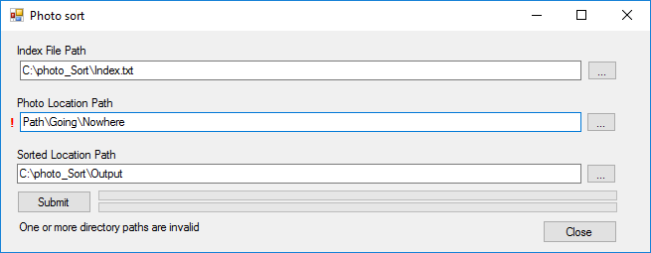

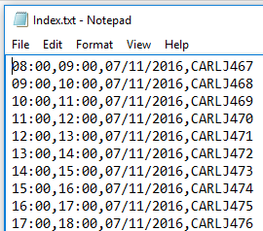The first field is intended for the Index file (shown on the right) with instructions for what span of time on what date and what folder to store the image.

Next is the path to where the photos were stored, if there are multiple folders then use the folder that the others are contained in, the program will process each folder.

Lastly is the path to where the user would want the sorted images to be saved.

These fields can either be filled out manually by typing or pasting the path in, or there is a button on the edge of the field , this will open a file explorer where the user can navigate to the file/folder click “ok” then the path to the location will automatically be added to the text field.